Technical Specifications

*DYNATRACE – Management of alerts*

Follow up

**Informations générales**

|  |  |
| --- | --- |
| **Nom du fichier** | DYNATRACE – Technical Specifications to manage alerts.docx |
| **Version courante** | **V1.0** |
| **Date de la version** | **05/05/2025** |
| **Référence** |  |
| **Statut du document** |  |
| **Approuvé par** |  |
| **Autorisé par** |  |
|  |  |

**Historic**

|  |  |  |  |
| --- | --- | --- | --- |
| ****Ver.**** | ****Date**** | ****Autor(s)**** | ****Modification(s)**** |
|  |  |  |  |
|  |  |  |  |
|  |  |  |  |
|  |  |  |  |
|  |  |  |  |
|  |  |  |  |
|  |  |  |  |
|  |  |  |  |

**People helping to describe the document**

|  |  |  |
| --- | --- | --- |
| ****Nom**** | ****Rôle**** | ****Action(s)**** |
| **XXX** |  |  |
| **XXX** |  |  |
| **XXX** |  |  |
| **XXX** |  |  |
| **XXX** |  |  |
| **XXX** |  |  |

**Sending**

|  |  |
| --- | --- |
| **Interne** |  |
| **Client** |  |
| **Pour info** |  |

SUMMARY

1 Goals 5

2 Connector configuration 7

3 Types of alerts 8

3.1 Network devices 9

3.1.1 Alert types manageables 9

3.1.2 Alert types not working 10

3.1.2.1 Network access issue 10

3.1.2.2 Fault severity issue 10

3.1.2.3 Transaction time issue 10

3.2 Server systems 12

3.2.1 Alert types manageables 12

3.2.2 Alert types not working 12

3.2.2.1 URL check from a Safran server 12

3.2.2.2 Http check 13

3.2.2.3 Timeout from Http check 13

3.2.2.4 Error message from Http check 13

3.2.2.5 DNS error 14

3.2.2.6 Connectivity issue with a CI 14

3.2.2.7 Service status issue (from a specific technology) 14

3.2.2.8 Latency issue 15

3.2.2.9 Latency issue 15

3.2.2.10 Application low traffic 16

3.2.2.11 Request timeout 16

3.2.2.12 File System full 16

3.2.2.13 Http check (Unknown host) 17

3.3 Applications 18

3.3.1 Alert types not working 18

3.3.1.1 URL check from a Safran server 18

3.3.1.2 SSL communication error 18

3.3.1.3 URL check from a Safran server 19

3.3.1.4 Httml address issue 19

3.3.1.5 Unexpected error 20

3.4 Databases 21

3.4.1 Alert types not working 21

3.4.1.1 Database service issue 21

3.5 Printers 21

3.5.1 Alert types not working 21

3.5.1.1 URL check from a Safran server 21

4 Process 22

# Goals

Goals of this document are :

* Describe how Dynatrace sends alerts in Servicenow instance.
* Indicate the list of information sent in Servicenow for each type of event (depend on technology, infrastructure type, database, application).
* Specify rules activated to be sure that only events to manage are sending in the express list on target
* Explain the process to add a new infrastructure/application scope in alerting rules.

By these information, the reader could manage activities around Dynatrace alerting and allow support teams to manage alerts on the best way.

# Connector configuration

Configure the Dynatrace connector instance to receive raw data metrics analysis from the Dynatrace server.

**Prerequisites :**

To enable metrics collection, ensure that the MID Server extension that retrieves metrics is configured with the Metrics Analysis extension and that the extension is in started mode.

* Create a Dynatrace access token with the Read Metrics scope permissions (metrics.read) to enable the retrieval of metric data. This token is used in the connector to call the Dynatrace REST API.
* Configure the Service Graph Connector for Dynatrace. This option configures Dynatrace in the instance and detects CIs.

|  |  |
| --- | --- |
|  | Required role: evt_mgmt_admin |

By default, Dynatrace Connector detects CIs and supports metric collection for the following entity types:

* HOST
* APPLICATION
* SERVICE
* PROCESS_GROUP_INSTANCE

To configure others information to collect, apply steps below.

* Go to Event Management > Integrations > Connector Instances.
* Select New and create a connector instance.
* Select and hold (or right-click) the form header, then select Save.
* The connector instance values ​​are added to the form, and the relevant connector settings are displayed.
* In the MID Servers section for connectors, add a MID Server for the Dynatrace connector to use.
* In the Related Links section, select Configure Metrics to Collect. Only metrics with the value Active=true are collected by the instance.
* Configure the metrics you want the instance to collect with the value Active=true.
* Metrics with the value Active=false are not collected by the instance.

# Types of alerts

A Dynatrace alert is defined by this list of mandatory information to allow Support teams to manage it easily:

* Configuration Item
* Resource
* Description
* Support Group L1
* Support Group L2
* Support Group L3
* Environment
* Node

Beyond these information, some tags can be specified in Additional information to help to define the best rule to find the good value in the CMDB.

|  |  |
| --- | --- |
|  | Right now, the list of rules actives is : |

Dynatrace VM Event Rule [AWS and Google]

Dynatrace – General

Enrichi le CI pour ce qui vient de AWS, Google, Azure

Dynatrace – General Event Rule

Enrichi le CI pour tous les cas

Dynatrace Metrics Process Binding

Enrichi le CI par le Process ou l’application trouvée

Créé une variable Name pour faire le lien

Dynatrace Metrics Service/Application Binding

Enrichi le CI par le Service ou l’application trouvée

Créé une variable Name pour faire le lien

Dynatrace Service Event rule

Enrichi le CI qui est un service et pas un host

Créé une variable Name pour faire le lien

Dynatrace VM Event rule AWS and Google

Match avec Virtaul Machine Object

## Network devices

Example of alert view :



Table of use cases

|  |  |  |
| --- | --- | --- |
| **Use case** | **Rule name in target** | **Operational status** |
| Firewall |  |  |
| Switch |  |  |
| Metric check (url, latence,…) |  |  |
| Appliance |  |  |
| Load balancer |  |  |
| Router |  |  |
| Chassis |  |  |
| VPN |  |  |
| Wireless LAN Controller |  |  |
| Wireless Access Point |  |  |

Details of rules

### Alert types manageables

### Alert types not working

#### Network access issue



**Check definition :**

|  |  |
| --- | --- |
| **Use case** | **Rule name in target** |
| Description title | Network availability monitor outage |
| Check definition | Communication check |
| Information missing or to adapt | * Configuration Item not defined/recover * Resource corresponding at a functional test and not a hostname |

#### Fault severity issue

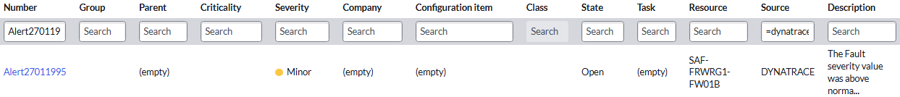

**Check definition :**

|  |  |
| --- | --- |
| **Use case** | **Rule name in target** |
| Description title | The Fault severity value was above normal behavior… |
| Check definition | Davis alerting for a specific technology |
| Information missing or to adapt | * Configuration Item not defined/recover * Resource corresponding at the network device name |

#### Transaction time issue

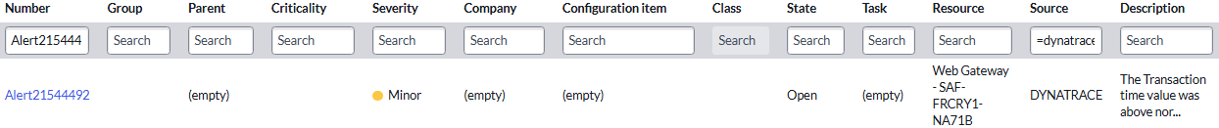

**Check definition :**

|  |  |
| --- | --- |
| **Use case** | **Rule name in target** |
| Description title | The Transaction time value was above normal behavior (**X** s) for Web Gateway - **XXXXXXXX** |
| Check definition | Performance event to check a web gateway from a network device |
| Information missing or to adapt | * Node and Resource contained are on type “Web Gateway – network device name” * Configuration Item don’t receive the network device name |

## Server systems

### Alert types manageables

Example of alert view :



Table of use cases

|  |  |  |
| --- | --- | --- |
| **Use case** | **Rule name in target** | **Operational status** |
| Firewall |  |  |
| Switch |  |  |
| Metric check (url, latence,…) |  |  |
| Appliance |  |  |
| Load balancer |  |  |
| Router |  |  |
| Chassis |  |  |
| VPN |  |  |
| Wireless LAN Controller |  |  |
| Wireless Access Point |  |  |

Details of rules

### Alert types not working

#### URL check from a Safran server



**Check definition :**

|  |  |
| --- | --- |
| **Use case** | **Rule name in target** |
| Description title | {dims:dt.entity.python:com_dynatrace_extension_netscaler_interface.interface_id} State changed from UP |
| Check definition | Alerts from Synthetic agent to check an application url with hostname specified into the url |
| Information missing or to adapt | * Configuration Item not defined/recover * Resource contained the url checked (like in Description cell) |

#### Http check



**Check definition :**

|  |  |
| --- | --- |
| **Use case** | **Rule name in target** |
| Description title | Connection refused from **X** locations |
| Check definition | Alerts from Synthetic agent to check any urls |
| Information missing or to adapt | * Configuration Item not defined/recover |

#### Timeout from Http check



**Check definition :**

|  |  |
| --- | --- |
| **Use case** | **Rule name in target** |
| Description title | Connection refused, Request timeout from **X** locations |
| Check definition | Alerts from Synthetic agent to check any urls. Timeout issue |
| Information missing or to adapt | * Configuration Item not defined/recover |

#### Error message from Http check

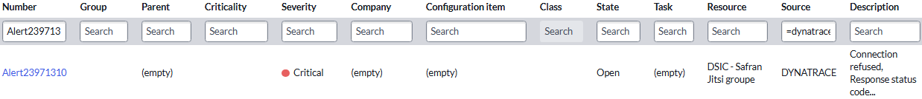

**Check definition :**

|  |  |
| --- | --- |
| **Use case** | **Rule name in target** |
| Description title | Connection refused, Response status code rules violated, 500… |
| Check definition | Alerts from Synthetic agent to check any urls. Connection issue |
| Information missing or to adapt | * Configuration Item not defined/recover |

#### DNS error



**Check definition :**

|  |  |
| --- | --- |
| **Use case** | **Rule name in target** |
| Description title | DNS lookup failed for dynatrace.group.safran (DNS:… |
| Check definition | Synthetic monitor outage to check DNS address |
| Information missing or to adapt | * Configuration Item not defined/recover |

#### Connectivity issue with a CI

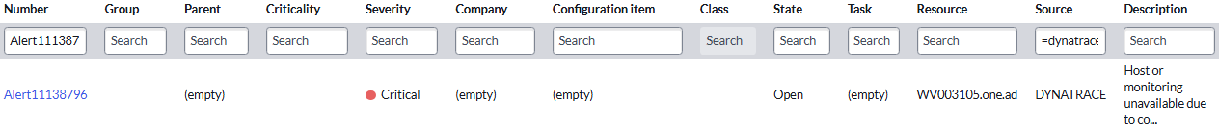

**Check definition :**

|  |  |
| --- | --- |
| **Use case** | **Rule name in target** |
| Description title | Host or monitoring unavailable due to connectivity issues or server outage |
| Check definition | Host or monitoring unavailable |
| Information missing or to adapt | * Hostname is recover in Resource cell instead of Configuration Item |

#### Service status issue (from a specific technology)



**Check definition :**

|  |  |
| --- | --- |
| **Use case** | **Rule name in target** |
| Description title | Service status changed |
| Check definition | Change status for a service (can be different by technology) |
| Information missing or to adapt | * Hostname is recover in Resource cell instead of Configuration Item |

#### Latency issue

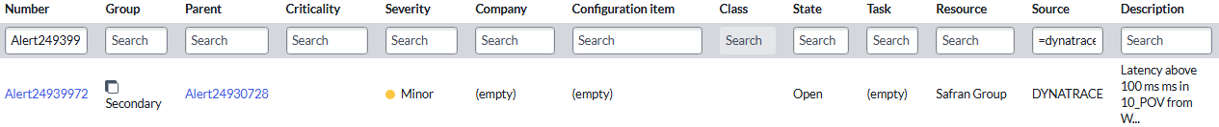

**Check definition :**

|  |  |
| --- | --- |
| **Use case** | **Rule name in target** |
| Description title | Access time issues or server outage |
| Check definition | Threshold past for delay |
| Information missing or to adapt | * Hostname is recover in Resource cell instead of Configuration Item |

#### Latency issue



**Check definition :**

|  |  |
| --- | --- |
| **Use case** | **Rule name in target** |
| Description title | Access time issues or server outage |
| Check definition | Threshold past for delay |
| Information missing or to adapt | * Hostname is recover in Resource cell instead of Configuration Item |

#### Application low traffic



**Check definition :**

|  |  |
| --- | --- |
| **Use case** | **Rule name in target** |
| Description title | Observed **xx.xx** actions/min, expected value was **xx.xx** actions/min  Or  The current number of user actions (**X.X**) dropped below the auto-detected baseline (**X.X**)  Or  The current response time (~**X.X** ms) exceeds the auto-detected baseline (~**X.X** ms) by **XX.XX** % |
| Check definition | Check number of actions. If not corresponding at a normal/classic value, send an alert |
| Information missing or to adapt | * Hostname is recover in Resource cell instead of Configuration Item |

#### Request timeout



**Check definition :**

|  |  |
| --- | --- |
| **Use case** | **Rule name in target** |
| Description title | Response status code rules violated, 502: Bad gateway from **X** locations |
| Check definition | Check communication status from **X** locations |
| Information missing or to adapt | * Hostname is recover in Resource cell instead of Configuration Item |

#### File System full



**Check definition :**

|  |  |
| --- | --- |
| **Use case** | **Rule name in target** |
| Description title | The total available space on disk **XXXXXXXXX** is lower than **XX** % |
| Check definition | Check free diskspace |
| Information missing or to adapt | * Hostname is recover in Resource cell instead of Configuration Item * Resource is a functional name, not the hostname on target |

#### Http check (Unknown host)



**Check definition :**

|  |  |
| --- | --- |
| **Use case** | **Rule name in target** |
| Description title | Unknown host, Request timeout, Response status code rules violated, 502: Bad gateway from **X** locations |
| Check definition | Http check |
| Information missing or to adapt | * Hostname is recover in Resource cell instead of Configuration Item * Resource is a functional name, not the hostname on target |

## Applications

### Alert types not working

#### URL check from a Safran server



**Check definition :**

|  |  |
| --- | --- |
| **Use case** | **Rule name in target** |
| Description title | Request timeout from **X** locations |
| Check definition | Check delay to send an application packet of datas in several locations |
| Information missing or to adapt | * Configuration Item not defined/recover * Resource contained a functional name instead of hostname or application service |

#### SSL communication error

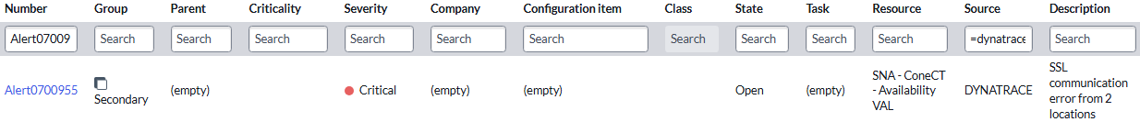

**Check definition :**

|  |  |
| --- | --- |
| **Use case** | **Rule name in target** |
| Description title | SSL communication error |
| Check definition | Check access to the application on target  Several causes for SSL alerts :   * SSL communication error from **X** locations * SSL communication error, Connection refused from **X** locations * SSL communication error, Connection refused, Request timeout from **X** locations * SSL communication error, Connection refused, Response status code rules violated, 500: Internal server error from **X** locations * SSL communication error, Request timeout from **X** locations * SSL communication error, Request timeout, Response status code rules violated, 502: Bad gateway from **X** locations * SSL communication error, Response status code rules violated, 500: Internal server error from **X** locations * SSL communication error, Response status code rules violated, 500: Internal server error, Response status code rules violated, 502: Bad gateway from **X** locations * SSL communication error, Response status code rules violated, 502: Bad gateway from **X** locations |
| Information missing or to adapt | * Configuration Item not defined/recover * Resource contained a functional name instead of hostname or application service |

#### URL check from a Safran server



**Check definition :**

|  |  |
| --- | --- |
| **Use case** | **Rule name in target** |
| Description title | Synthetic monitor duration slowdown from … |
| Check definition | Check an application from multiple global locations.  Alert is sending as soon as an user-defined performance threshold on one of the configured locations isn't met |
| Information missing or to adapt | * Configuration Item not defined/recover * Resource contained a functional name instead of hostname or application service |

#### Httml address issue

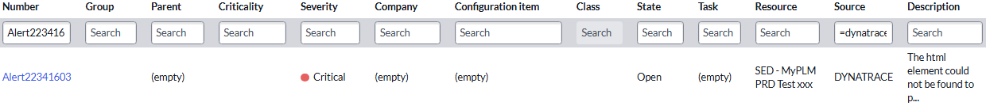

**Check definition :**

|  |  |
| --- | --- |
| **Use case** | **Rule name in target** |
| Description title | The html element could not be found to perform action from … |
| Check definition | Check an application from multiple global locations.  The message indicates that one of the elements defined in your clickpath can’t be found. You can have a look at the locators used to find the element in the clickpath settings. |
| Information missing or to adapt | * Configuration Item not defined/recover * Resource contained a functional name instead of hostname or application service |

#### Unexpected error



**Check definition :**

|  |  |
| --- | --- |
| **Use case** | **Rule name in target** |
| Description title | Unexpected error from **X** locations |
| Check definition | Synthetic location check.  Several titles possibles :   * Unexpected error from **X** locations * Unexpected error, Connection refused from **X** locations * Unexpected error, Connection timeout, Request timeout from **X** locations |
| Information missing or to adapt | * Configuration Item not defined/recover * Resource contained a functional name instead of hostname or application service |

## Databases

### Alert types not working

#### Database service issue



**Check definition :**

|  |  |
| --- | --- |
| **Use case** | **Rule name in target** |
| Description title | The error rate increased to **X.XX** %. Service **XXXXXX** has a failure rate increase. |
| Check definition | Failure rate increase |
| Information missing or to adapt | * Hostname is recover in Resource cell instead of Configuration Item * No link between SQL database and the server * Node contained the SQL instance name with fqdn from subsidiary |

## Printers

### Alert types not working

#### URL check from a Safran server



**Check definition :**

|  |  |
| --- | --- |
| **Use case** | **Rule name in target** |
| Description title | The **XX** Printers request locktime above threshold value was above normal behavior.\nexceeded allowed **X** s s |
| Check definition | Check locktime threshold defined for a printer |
| Information missing or to adapt | * Configuration Item not defined/recover * Resource contained “default-host (/printers)” instead of printer name |

# Process

To add new rule, it’s necessary to respect process below :